JWT Authentication in Spring Boot – Step-by-Step Implementation

Step 1: Create a Spring Boot Project
Use Spring Initializr or your IDE (like Spring Tool Suite or IntelliJ) to create a Maven-based Spring Boot project with the following dependencies:
- spring-boot-starter-web
- spring-boot-starter-security
- jjwt-api
- jjwt-impl
- jjwt-jackson
Sample pom.xml Dependencies
xml
CopyEdit
<dependencies>
<dependency>
<groupId>org.springframework.boot</groupId>
<artifactId>spring-boot-starter-web</artifactId>
</dependency>

<dependency>
<groupId>org.springframework.boot</groupId>
<artifactId>spring-boot-starter-security</artifactId>
</dependency>

<dependency>
<groupId>io.jsonwebtoken</groupId>
<artifactId>jjwt-api</artifactId>
<version>0.11.5</version>
</dependency>

<dependency>
<groupId>io.jsonwebtoken</groupId>
<artifactId>jjwt-impl</artifactId>
<version>0.11.5</version>
<scope>runtime</scope>
</dependency>

<dependency>
<groupId>io.jsonwebtoken</groupId>
<artifactId>jjwt-jackson</artifactId>
<version>0.11.5</version>
<scope>runtime</scope>
</dependency>
</dependencies>
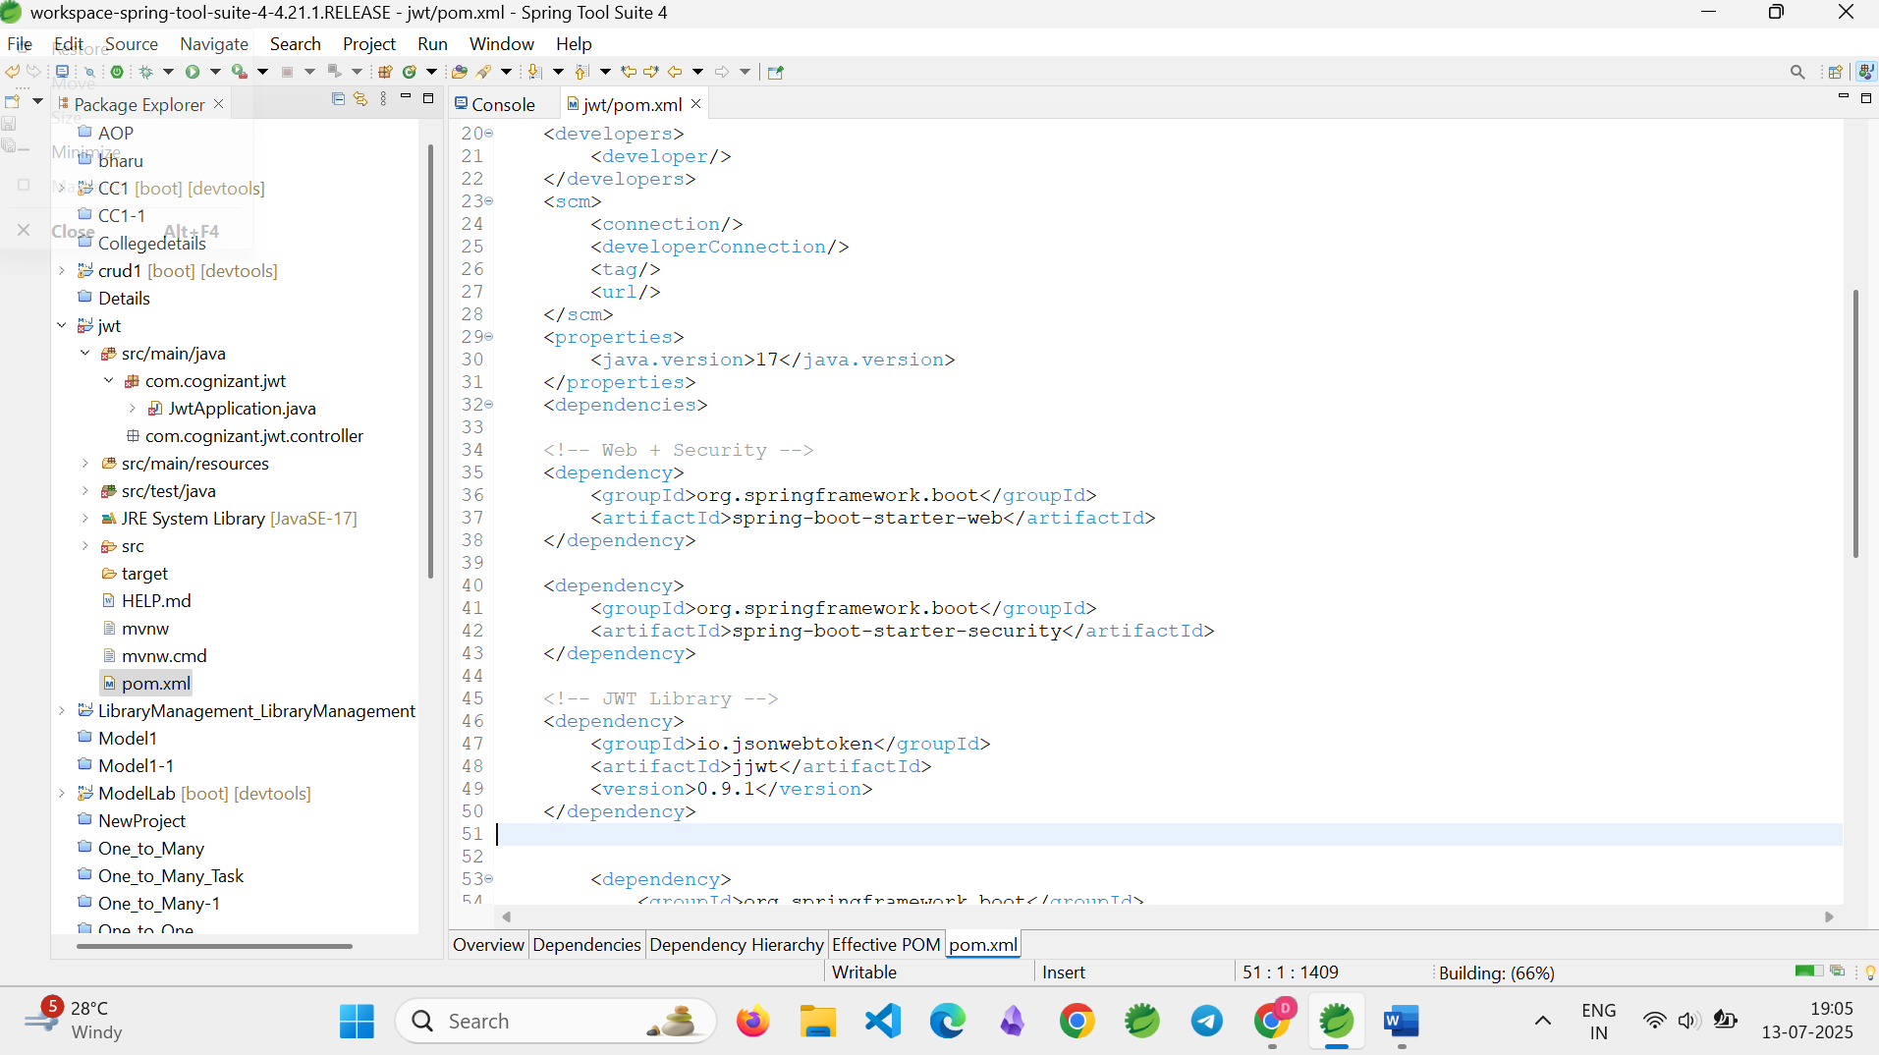

Step 2: Configure Application Port
Open src/main/resources/application.properties and add the following line:
server.port=8091
This sets the application to run on port 8091.

Step 3: Create the Main Application Class
Create a main class named JwtApplication.java in the base package:
@SpringBootApplication
public class JwtApplication {
public static void main(String[] args) {
SpringApplication.run(JwtApplication.class, args);
}
}

Step 4: Create the JWT Service
Create a class JwtService.java under com.cognizant.jwt.service.
@Service
public class JwtService {

private final String secretKey = "myverysecuresecretkey123456789012";

public String[] extractCredentials(String authHeader) {
if (authHeader != null && authHeader.startsWith("Basic ")) {
String base64Credentials = authHeader.substring("Basic ".length());
byte[] decoded = Base64.getDecoder().decode(base64Credentials);
String credentials = new String(decoded);
return credentials.split(":", 2);
}
throw new RuntimeException("Missing or invalid Authorization header");
}

public String generateToken(String username) {
long now = System.currentTimeMillis();
long expiry = now + (10 * 60 * 1000);

Key key = Keys.hmacShaKeyFor(secretKey.getBytes());

return Jwts.builder()
.setSubject(username)
.setIssuedAt(new Date(now))
.setExpiration(new Date(expiry))
.signWith(key, SignatureAlgorithm.HS256)
.compact();
}
}
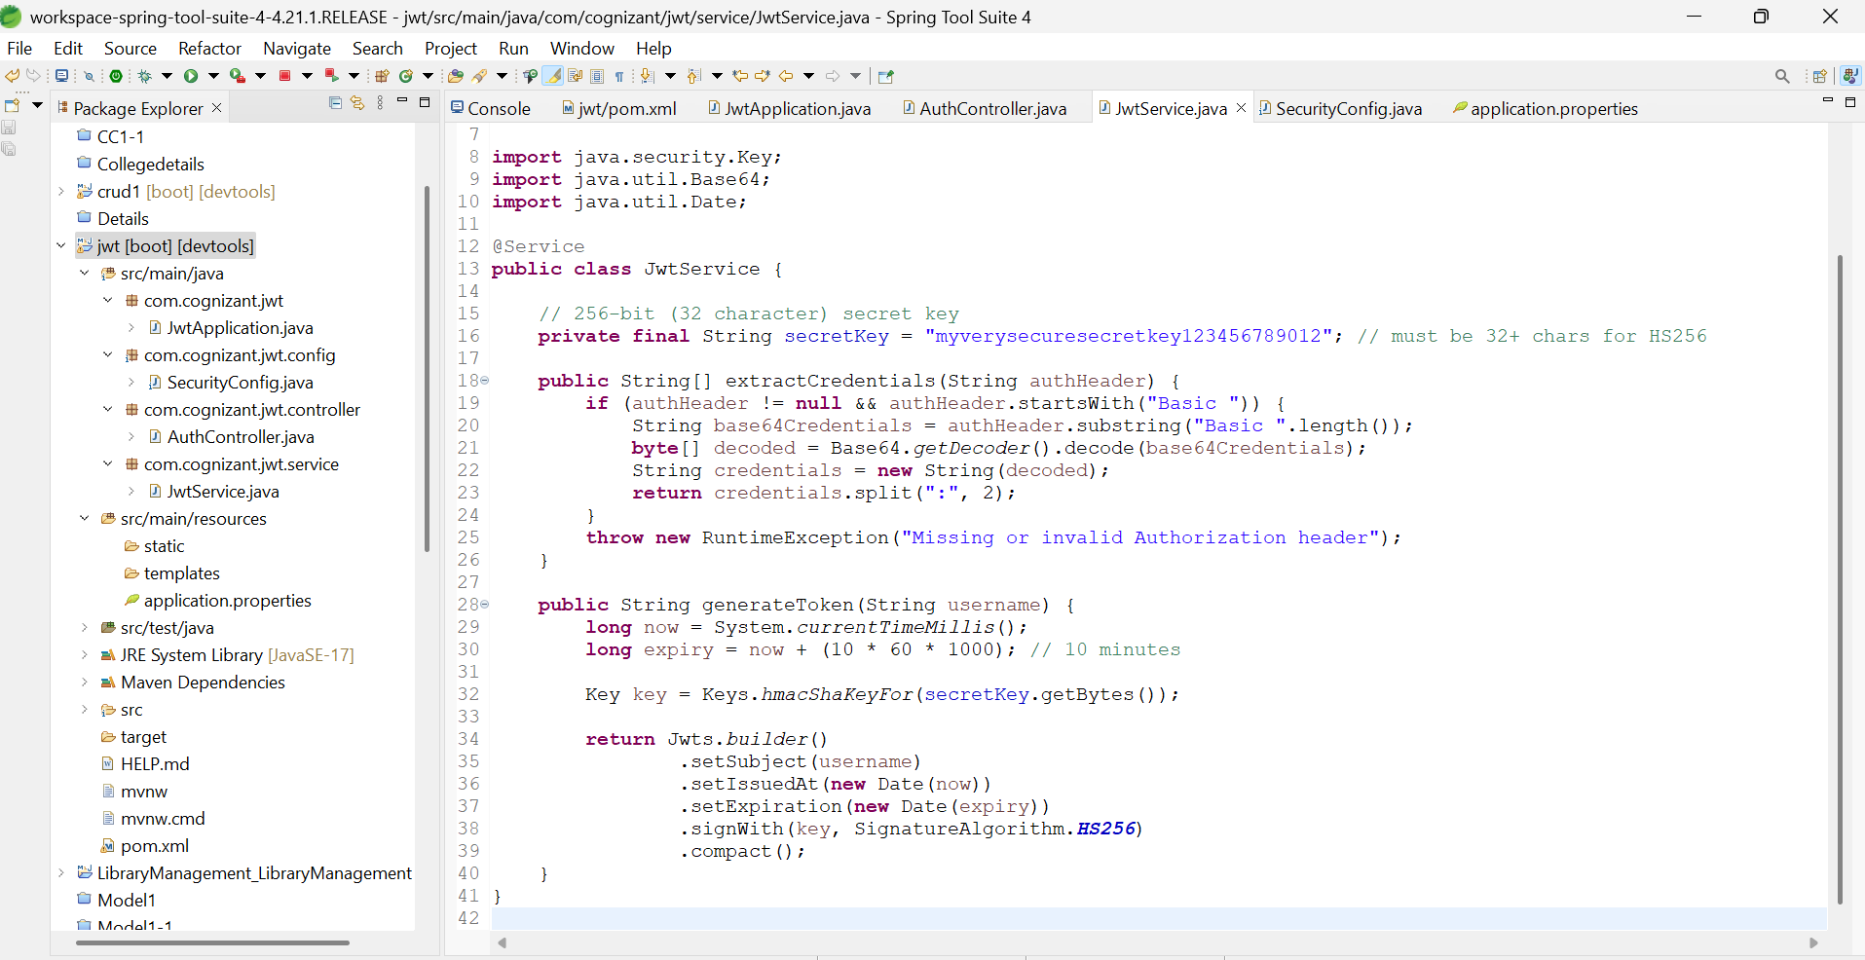

Step 5: Create the Authentication Controller
Create a class named AuthController.java under com.cognizant.jwt.controller.
@RestController
public class AuthController {

@Autowired
private JwtService jwtService;

@GetMapping("/authenticate")
public ResponseEntity<Map<String, String>> authenticate(@RequestHeader("Authorization") String authHeader) {
try {
String[] creds = jwtService.extractCredentials(authHeader);
String username = creds[0];
String password = creds[1];

if ("user".equals(username) && "pwd".equals(password)) {
String token = jwtService.generateToken(username);
return ResponseEntity.ok(Collections.singletonMap("token", token));
} else {
return ResponseEntity.status(HttpStatus.UNAUTHORIZED).build();
}
} catch (Exception e) {
return ResponseEntity.status(HttpStatus.UNAUTHORIZED).build();
}
}
}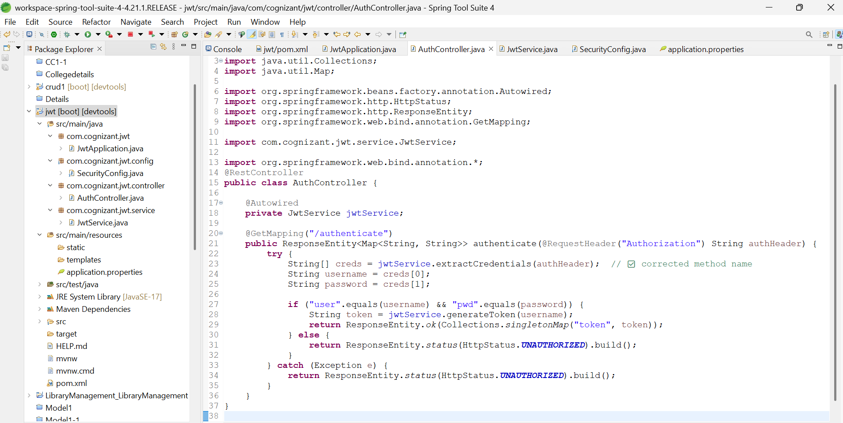

Step 6: Configure Spring Security
Create a configuration class SecurityConfig.java under com.cognizant.jwt.config.
@Configuration
@EnableWebSecurity
public class SecurityConfig {

@Bean
public SecurityFilterChain filterChain(HttpSecurity http) throws Exception {
http
.csrf(csrf -> csrf.disable())
.authorizeHttpRequests(auth -> auth
.requestMatchers("/authenticate").permitAll()
.anyRequest().authenticated());
return http.build();
}

@Bean
public UserDetailsService userDetailsService() {
return username -> null;
}
}
This disables CSRF, allows access to the /authenticate endpoint without authentication, and disables Spring Boot’s default user authentication.
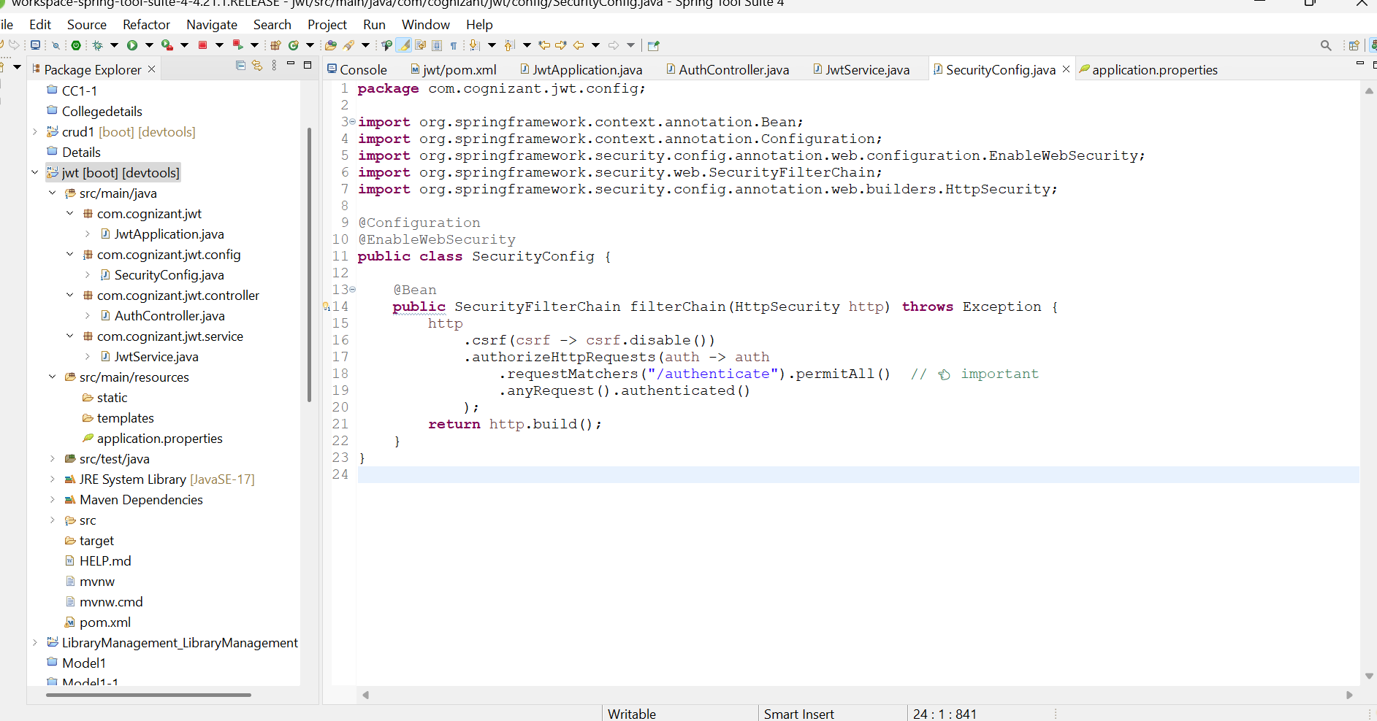
Step 7: Test the JWT Authentication Endpoint
Use curl or Postman to test the /authenticate endpoint.
curl -u user:pwd http://localhost:8091/authenticate
Expected Output:
{
"token": "eyJhbGciOiJIUzI1NiJ9..."
}
Postman:
- Method: GET
- URL: http://localhost:8091/authenticate
- Authorization tab: Basic Auth (username = user, password = pwd)
If password wrong
401 error Unauthorized
